**Page Layout**

1. Open design manager

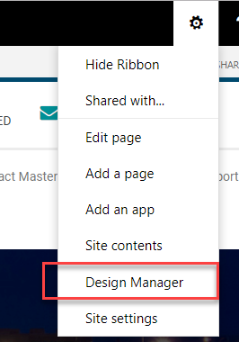

1. Create Edit page Layout and click on then click “create a page layout”

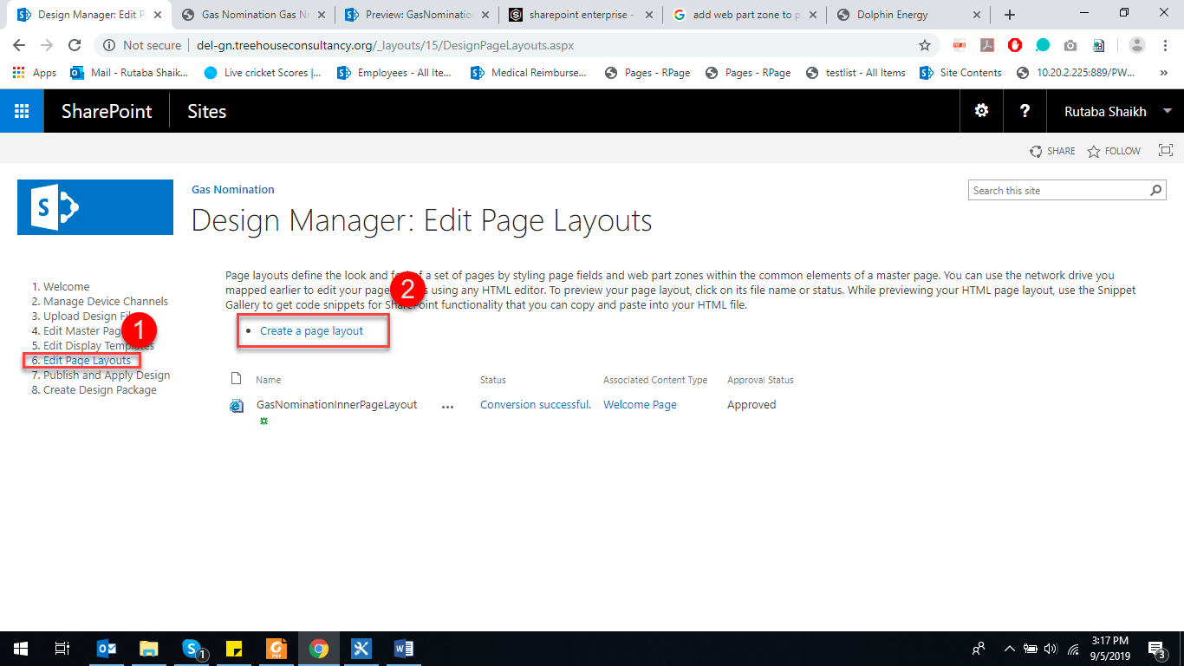

1. Write name of your page layout select Master Page and press ok

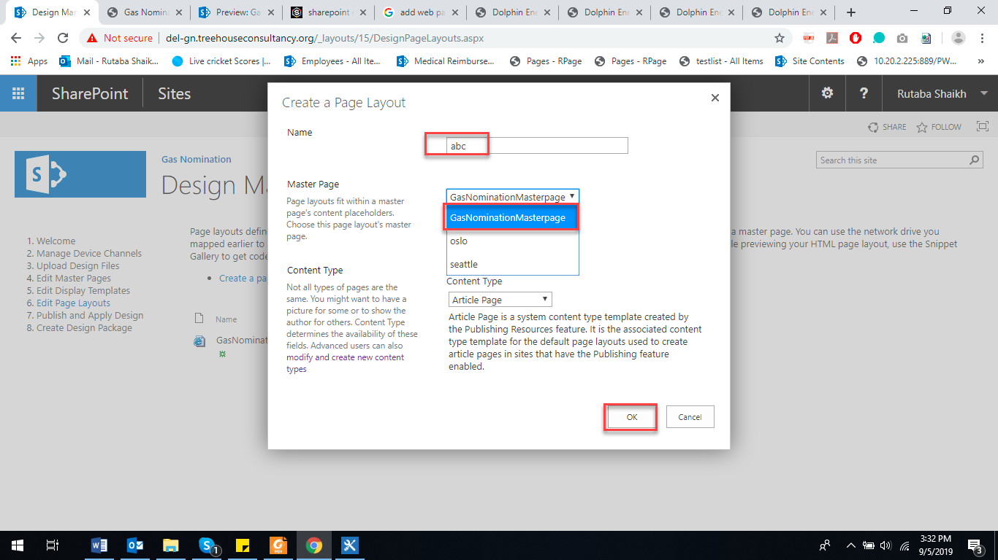

1. To add a webpart Zone, click on Snippets and On the ribbon, on the Design tab, choose Web Part zone. Copy html and paste it in your html file under **<!--MS:<asp:ContentPlaceHolder ID="PlaceHolderMain" runat="server">-->** tag

(as I have added banner and breadcrump that’s why tag is this).

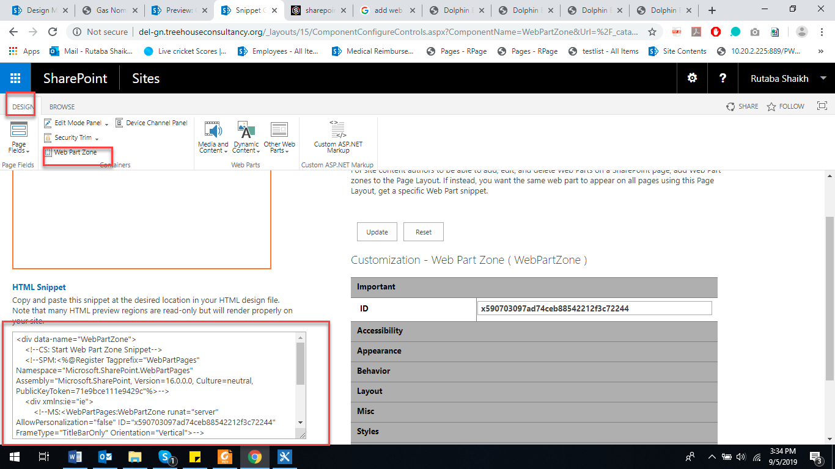

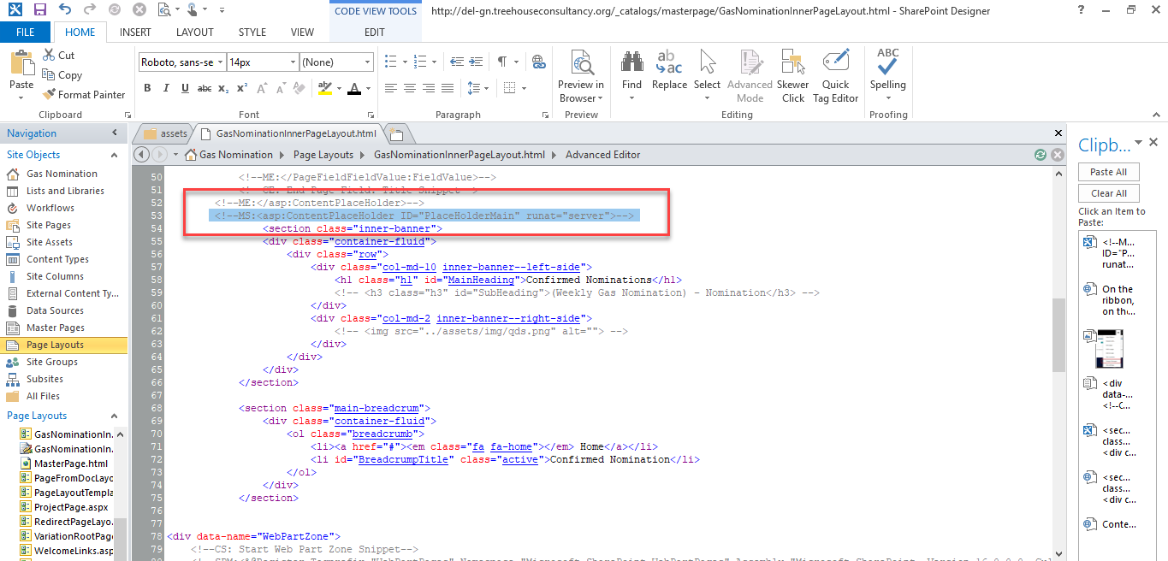

1. Goto site settings >> Master Page. Select your page layout under Site Master Pagr>>Default Drop down

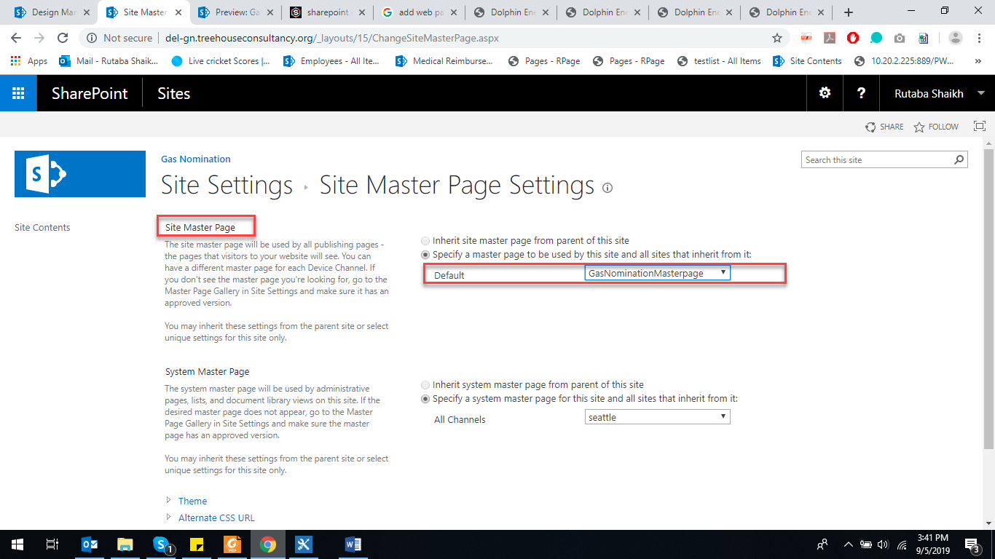

Then make your page normally and select its layout.